ERD Diagram

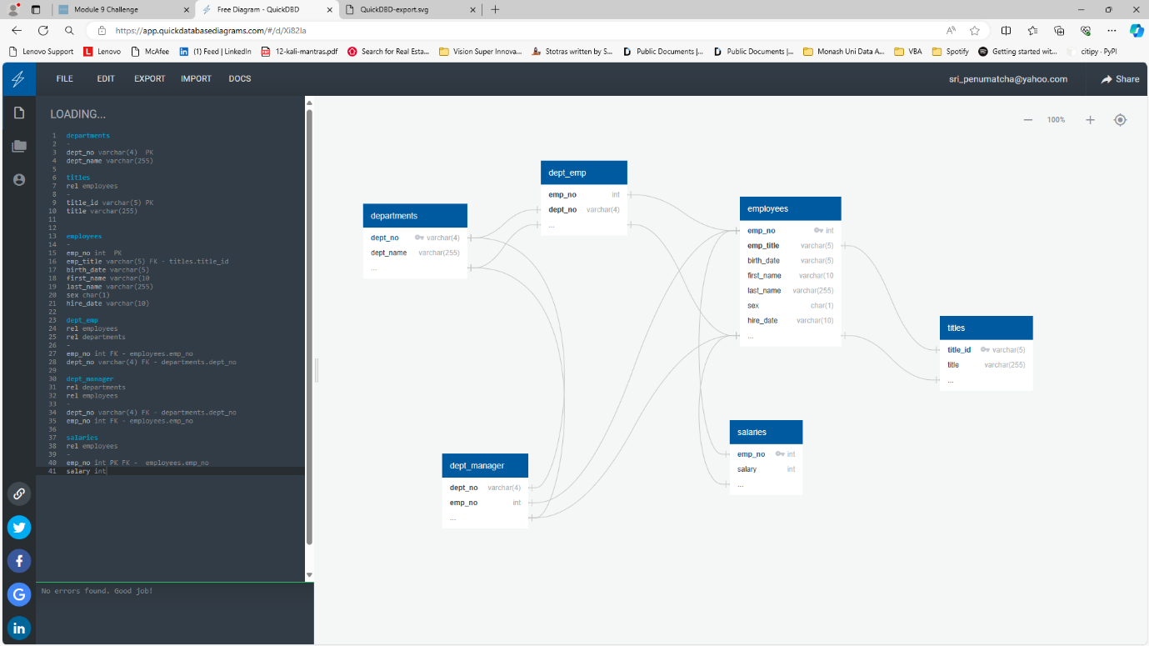

Scheme.sql

Import the data from departments.csv into departments table

Import the data from titles.csv into titles table

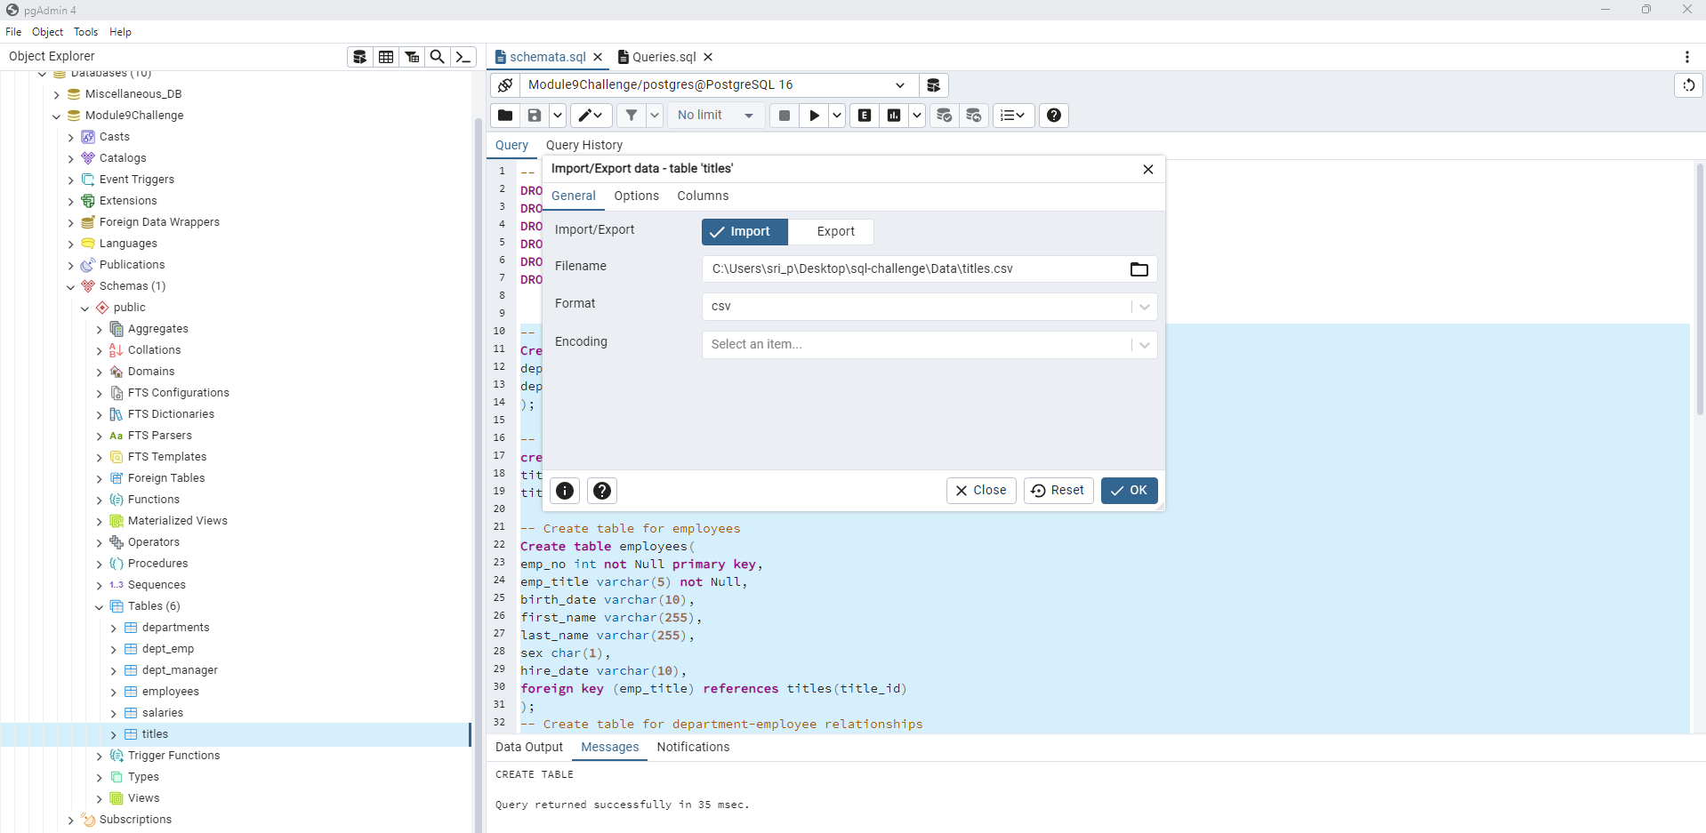

Import the data from employees.csv into employees table.

Import the data from dept_emp.csv into dept_emp table.

Import the data from dept_manager.csv into dept_manager table.

Import the data from salaries.csv into salaries table.

Run select statements to view the records.

Data Analysis

